Module 2: Authentic Assessments and Informal Reading Inventories
Here is your second Module. When you complete a module, imagine we are doing work together for the equivalent to 5 hours’ worth of classes. If we were meeting face to face we would meet two times a week in an 8 week class for approximately 2.5 hours each time. Additionally, you would have readings and other assignments as homework. So please allot appropriate time to complete each module. Do not worry too much about making it perfect since if you go off-track I always allow you to fix your work. This is what is called “formative assessment” when I measure what you know so I can figure out what else I need to teach or assist you with before the summative assessment (in this case the final).
There are several tasks you need to complete below. It is best to download the attached document on to your hard drive and put in your answers in a different color or using highlights. Make sure you save it on your hard drive! Then upload to the assignment dropbox when you are done. The way you do this is under “Course Content” click on the assignment and it will give you the options to either insert text or upload a document. There are several tasks below that should be done in sequence. There are several tasks below that should be done in sequence. All of the examples are in italics.
1. Blooms Taxonomy and Project Based Learning
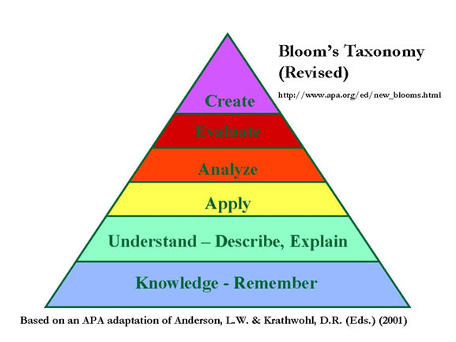
Give another look at the handout, "Bloom's Taxonomy and Student Assessment." Now that you have an idea how to write test questions, write possible projects you could have students do to demonstrate Application, Analysis, Evaluation, and Creation (one project for each). Please either use the same standard/goal/objective or learning outcome you used from Module 1 test questions or choose a new standard.

Subject Area: ________________________________________________________________
Standard: ____________________________________________________________________
Bloom’s Taxonomy Level | Type of Project Based Learning
Application
Analysis
Evaluation
Creation

2. Making Rubrics
Projects are a wonderful way to give students differentiated instruction in the classroom. But the problem is how to grade the projects. It is best to give the students a grading rubric when you are giving the directions to the project. That way they know how they will be graded beforehand. If you notice I have been giving you grading rubrics along with each Module.
If you were to assign the four projects you selected for Question 1, use Rubistar to show me how you grade 4 different projects on 4 items each: http://rubistar.4teachers.org/index.php
For example, show me how you would grade a Multimedia Presentation and Making a Game. For each chose a minimum of 4 items you are grading them on.
It is best to provide your name, zip code (you can use mine- 28403) and a title. Then submit your rubric. Then you can either download it or just copy and paste it into a MS word document to turn into the dropbox.
3. Informal Reading Inventories
Can all of your students read the textbook you chose? Read the handout on "Creating Informal Reading Inventories." Then find a one hundred word passage from the textbook you either are using for your teaching, or another textbook you have access to, or find an online textbook or passage to use for illustrative purposes.
a) Type out, copy and paste, or scan the 100 word passage.
b) Create 5 comprehension questions for passage you chose. Make sure two questions are factual and two are inferential (inferential - based on interpretation; not directly expressed). The fifth can ask about the meaning of a vocabulary word.
c) If a student read the passage with 7 oral reading mistakes and missed 2 of the 5 questions, what level would you say it was on according to the handout? Why?
d) In math, science, and social studies, and language arts students also need to learn how to understand graphics, photos, graphs, charts and maps. Write one comprehension question each for any two graphics found in your textbook.
Example:
a). The hundred word passage is between the brackets:
Anyone, in theory, can publish on the Web; therefore, it is imperative for users of the Web to develop a critical eye to evaluate the credibility of Internet information. [Searching for sources on the WWW involves using a search engine, a directory, or some combination of these two. Because there is so much information on the Web, good and bad, finding what you want is not an exact science and can be time consuming. According to Nicholas C. Burbules, "....the Web is not an ordinary reference system; it poses some unique and, in many respects, unprecedented conditions that complicate the task of sorting out dependable from undependable information--and even complicates the notion that we have a clear sense of that distinction. How to differentiate credible from fraudulent information]is not a new problem, but unraveling these in the context of a vast rapidly changing networked system is" (Paradoxes of the Web: The Ethical Dimensions of Credibility, Library Trends, Wntr 2001 v49 i3 p441, Introduction).
Taken from: http://mason.gmu.edu/~montecin/web-eval-sites.htm
b)
Factual: What is needed to find sources on the Internet?
Factual: Is searching the Internet an exact science?
Inferential: Why is searching for credible sources time consuming?
Inferential: Who puts the non-credible sources on the Internet?
Vocabulary: What does WWW stand for?
d)
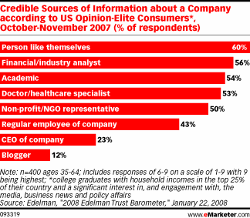
Taken from http://shivsingh.com/goingsocial/images/emarketer.gif
What do people find the least credible source when finding out about companies?
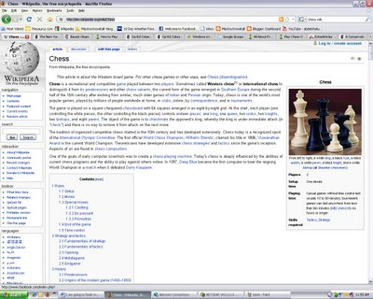
Taken from: http://shahmaat.blogspot.com/2009/03/credible-versus-non-credible-sources.html
Why is Wikipedia one of the examples of a non-credible source?

Grading Rubric: 10 points total ( How I am grading you!)

Task | Not completed or poorly done | Acceptable work | Exceptional work
Question 1: 2 points, .5 point for each project | 0 points  Incomplete or inaccurate work. | 1 points  Less than 4 projects or not put with plausible level of Bloom’s taxonomy | 2 points  Four Projects aligned with Bloom’s taxonomy
Question 2: 4 points, 1 for each rubric | 0 points  Incomplete or inaccurate work. | 2 points  Less than 4 rubric or have less than 4 items | 4 points  Four rubrics with 4 items to be graded
Question 3: 4 points, 1 point each for a,b,c,d | 0 points  Incomplete or inaccurate work. | 2 points  abcd incomplete or major errors | 4 points  abcd completed, ok if minor errors

