Module 1 Standards-based/curriculum-based assessments
Here is your first Module. When you complete a module, imagine we are doing work together for the equivalent to 5 hours worth of classes. If we were meeting face to face we would meet two times a week in an 8 week class for approximately 2.5 hours each time. Additionally, you would have readings and other assignments as homework. So please allot appropriate time to complete each module. Do not worry too much about making it perfect since if you go off-track I always allow you to fix your work. This is what is called “formative assessment” when I measure what you know so I can figure out what else I need to teach or assist you with before the summative assessment (in this case the final).
There are several tasks you need to complete below. It is best to download the attached document on to your hard drive and put in your answers in a different color or using highlights. Make sure you save it on your hard drive! Then upload to the assignment dropbox when you are done. The way you do this is under “Course Content” click on the assignment and it will give you the options to either insert text or upload a document. There are several tasks below that should be done in sequence. There are several tasks below that should be done in sequence. All of the examples are in italics.
- Before we start making tests, let’s learn some assessment terminology.
Sorry to do this but I need to make sure you know the vocabulary. I have a lot of terms here and I would like for you to find a definition from a fairly reliable source and to give one real example, hopefully as many as possible from your experience in Belize. Here is a graphic organizer for you to fill out to help you with this task.

Term | Definition | Example
Assessment
Test
Evaluation
Formative Assessment
Summative Assessment
Formal Assessment
Informal Assessment
Standardized Tests
Norm-Referenced Tests
Criterion Referenced Tests
Curriculum-Based Assessments
Continuous assessment
Final Assessment
Authentic Assessment
Performance Based Assessments
High Stakes Testing

Here are some resources I found but you will still have to do a little research on your own.
Assessment Glossary: http://www.questionmark.com/us/glossary.aspx
Assessment vs. Evaluation: http://global.cscc.edu/assessment/AssessEval.shtml
Assessment, Testing, Evaluation and Grading: http://www.umdnj.edu/idsweb/idst5350/assess_eval_test_grade.htm
Types of Tests: http://www.educationoasis.com/curriculum/assessment/typestests.htm

- Online testing tools
Even though in this module you have to create tests, I am fine if you “steal” the questions. You are welcomed to use your already created tests, online tests, the questions from your text book or even those written by colleagues. I am a big believer that you should always use tools to save you time as a teacher. So here are some websites to help you do that.
Test Designer (great site but some answers are incorrect!) http://www.testdesigner.com/
Also there are several online quiz makers for free:
http://www.quiz-creator.com/blog/2009/09/free-online-quiz-creator-software-create-online-quizzes/
You can search for online quizzes in whatever subject you teach and see what is already out there.
For high school math teachers here are some additional tools:
http://www.freemathtest.com/ (Pre Algebra)
http://www.aplusmath.com/Worksheets/index.html (Basic Algebra)
http://mathonline.missouri.edu/ (Calculus)

- Let’s Choose a Standard!
Choose one standard or objective or study outcome that you taught this year, will be teaching or would like to teach in a hypothetical class. Your standards I found were at the Belize Ministry of Education website below for primary students. If you have other standards than these, please let me know.
Primary curriculum: http://www.moe.gov.bz/index.php?option=com_content&view=article&id=48&Itemid=58
Secondary curriculum: http://people.uncw.edu/robertsonj/Belize/

Here is an example from my country and state: Taken from North Carolina Essential Standards, Grades 9-12, Information and Technology Essential Standards

HS.SI.1Evaluate resources needed to solve a given problem.
Taken from: http://www.ncpublicschools.org/docs/acre/standards/new-standards/info-technology/grades9-12.pdf
You can choose any grade level and any content area that is appropriate for you. I will mostly focus on secondary content for this class.
Which standard did you choose? ____________________________________________________

4. Writing Test Questions
Now that you have identified what it is you want to teach, look over the curriculum plan for that standard. It should help you to determine the tasks and steps a student needs to know in order to master the objective. This will help you to figure out how to assess the student’s learning. Often we can assess student learning through authentic assessments where we observe and record student work productivity which we will do in Module 2. But sometimes we need to give a test. Read the handout "Types of Test Questions." Construct test questions for your objectives. Make or find three different types of questions, your choice. For an online textbook on test construction as well as tons of examples you may want to look at "How to Write Tests for Students." Since you will write or find 18 questions for the next item you are welcomed to combine number 3 with number 4. You can use existing questions from the teacher’s guide of the textbook or from online resources.
Example: (Taken from http://www.testdesigner.com/)
Which of the following is a TRUE statement?
- You are free to copy information you find and include it in a report.
- You should never consult Web sources when you are doing a research report.
- You do not have to cite the Web sources you use in your research report.
- Web sources must be cited in your report. You are not free to plagiarize.

5. Blooms Taxonomy and Test Questions
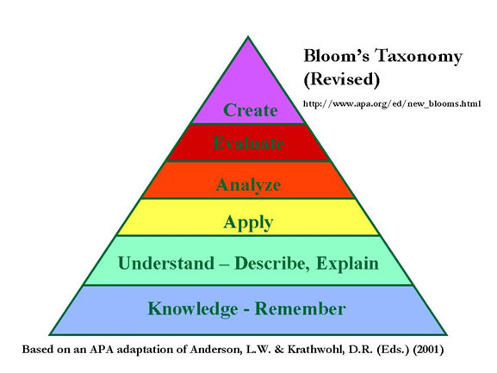
Read the handout, "Bloom's Taxonomy and Student Assessment." It is important not only to write test questions, but you need to make sure they address higher level of learning (application, analysis, evaluation and creation). This is very important to make sure your students become problem solvers, not just rote learners. Now that you have an idea how to write test questions, write one (different types) for each level of Blooms Taxonomy for your first “test”. Please provide the answer to each question for full points.
Here is a graphic organizer to help you complete this task:
Standard:
Level of Question | Question and Answer 1 | Question and Answer 2 | Question and Answer 3
Knowledge
Comprehension/Understand
Application
Analysis
Evaluation
Creation

Grading Rubric: 10 points total ( How I am grading you!)

Task | Not completed or poorly done | Acceptable work | Exceptional work
15 Definitions | 0 points  Incomplete or inaccurate work. | 2 points  Less than 14 accurate definitions form reliable sources | 2 points  14 accurate definitions form reliable sources
15 Examples | 0 points  Incomplete or inaccurate work. | 1 points  Less than 14 accurate examples from local sources if possible, if not find one’s from other locations | 2 points  14 accurate examples from local sources if possible, if not find one’s from other locations
Standard | 0 points  Incomplete or inaccurate work. | 1 points  Appropriate Belizean educational standard | 1 points  Appropriate Belizean educational standard
18 test questions with answers | 0 points  Incomplete or inaccurate work. | 4 points  Three different types of tests questions for each level of Blooms taxonomy (18 total) that may not always match the standard, or reflect the level of blooms taxonomy accurately, including the answer | 5 points  Three different types of tests questions for each level of Blooms taxonomy (18 total) that matches the standard, including the answer

